# California State University, Fresno

# DEPARTMENT OF COMPUTER SCIENCE

|  |  |  |  |  |  |
| --- | --- | --- | --- | --- | --- |
| Class: | **Algorithms & Data Structures** | | | Semester: | **Fall 2021** |
|  | | | | | |
| Points |  | Document author: | **Saishnu Ramesh Kumar** | | |
|  | Author’s email: | **saishnu_rk@mail.fresnostate.edu** | | |
| Laboratory number: | **Section 1, 11am to 12:50pm** | | |
|  | | | | | |

**1. Statement of Objectives**

For this lab, we had to create a Minimum Spanning Tree (MST) and it can be obtained using Prim’s or Kruskal’s algorithm. They are both greedy algorithms that find the MST. The objective of this lab was to get a better understanding of these two algorithms and how they are programmed/coded.

**2. Experimental Procedure**

For the Prim’s algorithm section, I created a function createMST which created an MST. The primsMST function would deal with getting the edge, cost, as well as the total cost of the MST. As for the Kruskal’s algorithm, a find and union function were first created as per the algorithm and was then followed by the kruskalMST function which also displays the edge, cost, and the total cost of the MST for the Kruskal algorithm. In the main function, the primsMST and kruskalMST were called to display the final output.

**3. Analysis**

Screenshot Terminal Output:

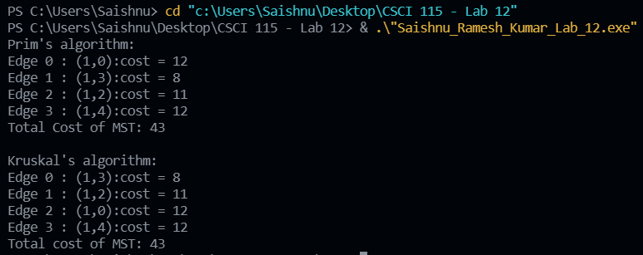

**4. Encountered Problems**

I came across a couple of compiler errors, but I was able to fix them and get the program compiling and running again.

**5. Conclusions**

This concept is also fairly new to me but after completing the lab assignment I believe that I have got a better understanding about how both of these algorithms work. It is interesting to learn how both algorithms function.

**6. References**

Slides provided by TA.

<https://www.geeksforgeeks.org/prims-minimum-spanning-tree-mst-greedy-algo-5/>

<https://www.geeksforgeeks.org/kruskals-minimum-spanning-tree-algorithm-greedy-algo-2/>